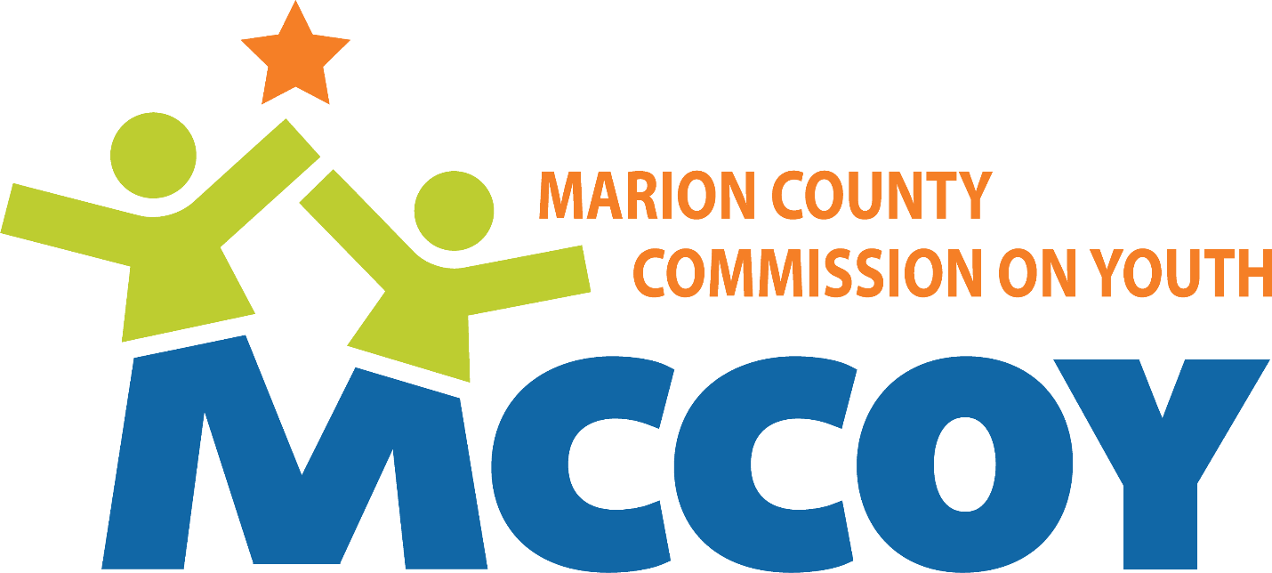
Strategic Plan -- 2026-2030
Expanding Reach • Deepening Impact • Strengthening Systems

Updated 11.23.2025

2025 Strategic Plan

Table of Contents
Pages
Executive Summary………………………………………………………….……………….. 3-5
The Plan
- Environment and situation for children in Marion County………….. 6-10
- The Network of Youth Services Support…………………………………. 11-12
- MCCOY – Where we are today………………………………………………. 12-19

Summary of Needs and Priorities………………………………………….. 19-21

MCCOY’s Strategic Framework -- Pillars and Priorities……………… 21-23
- MCCOY’s Current Programs Alignment with the Framework……… 23-26
- Program Growth and Development Assessment (2026–2030)…… 27-31
- MCCOY 3–5 Year Strategic Roadmap (2026–2030)………………….. 31-36
- Projected Impact by 2030 …………………………………………………… 36-39

Executive Summary
The Marion County Commission on Youth (MCCOY) stands at a pivotal moment. After more than 30 years of trusted leadership, advocacy, and collaboration, the organization is poised to deepen its impact through an ambitious five-year strategy designed to strengthen systems, build capacity, and empower the workforce that supports youth across Marion County.
The Context: Children and Youth in Marion County
Marion County’s more than 240,000 children face a complex mix of progress and persistent inequities. Child poverty has declined—from nearly 30% in 2017 to about 21% in 2023 (US Census Bureau)—and graduation rates are rising, but one in five children still lives in poverty (higher than both the state and national averages), and more than 30% of county schools are underperforming (IYI). Mental health challenges among youth have reached crisis levels: over 30% of youth report persistent sadness or hopelessness, and nearly one in four face mental, behavioral, or developmental challenges. (IYI)
Neighborhood disinvestment, unsafe spaces, and family stress compound these issues, making coordinated systems of care essential. The community must layer support—across schools, community organizations, health systems, families, and neighborhoods—to ensure that every young person has equitable opportunities to learn, grow, and thrive.
MCCOY’s Distinct Role
MCCOY occupies a unique position among Indiana’s intermediary organizations. While other partners such as the Indiana Youth Institute, Indiana Afterschool Network, and IYSA operate statewide or like EmployIndy within narrow sectors, MCCOY is the only organization solely focused on Marion County and on the full continuum of youth development—from education and mental health to family stability and civic engagement.
As a neutral convener, systems-level leader, and equity champion, MCCOY unites schools, nonprofits, policymakers, and funders to align resources, drive advocacy, and strengthen collaboration across the youth-serving ecosystem.
Organizational Strength and Readiness
MCCOY enters this next phase from a position of strength:
- A clear mission and respected reputation across Central Indiana.
- Stable operations, measurable community impact, and eight months of reserves.
- A diverse, talented team supported by strong governance and community partnerships.
Yet MCCOY’s growth is constrained by lean staffing, limited unrestricted funds, and a narrow funding base. Addressing these challenges through expanded development and marketing capacity is key to ensuring long-term sustainability and visibility.
Strategic Framework: 2026–2030
MCCOY’s strategy centers on three pillars that define its work:
- Strengthen Systems – Improve coordination, collaboration, and policy alignment across youth-serving organizations to better meet young people’s needs.
- Build Organizational Capacity – Equip agencies with training, evaluation tools, and partnerships to ensure long-term effectiveness and sustainability.
- Empower the Workforce – Enhance the wellbeing and professional development of those who serve youth.
These pillars are activated through three strategic approaches:
Advocacy, Education & Research, and Training & Development—all designed to advance three priority outcomes: Mental Wellness, Violence Reduction, and Youth Voice.
Program Priorities
Over the next five years, MCCOY will expand and integrate its flagship initiatives:
- Summer Youth Program – Deepen quality, collaboration, and access for 260+ summer programs.
- The Resilience Project – Scale countywide to strengthen educator wellbeing and student mental health.
- Youth Worker Well-Being Project – Sustain and embed mental health supports for the youth-serving workforce. Create metric and monitor youth-worker well-being across Marion County.
- Learning Network – create milestone/achievement program across and among more complete learning tracks, e.g., mental wellbeing, project management.
- To Rise Above Poverty (T.R.A.P.) – Grow into new communities to empower organization and their leaders to break cycles of generational poverty.
- Advocacy and Youth Voice – Elevate youth as a priority and more deeply embed youth perspectives in policy through key initiatives including Youth Day at the Statehouse, research and publications, the SoundOff Newsletter, Early Intervention Planning Council, and the Mayor’s Youth Leadership Council.
- Juvenile Advisory Council – Lead systemic efforts to reduce youth violence and reform justice practices.

Implementation Roadmap (2026–2030)
MCCOY’s five-year roadmap moves from foundation and infrastructure (2026–2027) to integration and expansion (2028–2029) and ultimately to sustainability and impact (2030).
Key milestones include:
- Strengthening leadership role as advocate for youth (2026-2027)
- Hiring a Development Director and marketing support (2026-2027)
- Expanding Resilience and T.R.A.P. programs to additional districts and neighborhoods (2026-2027)
- Establishing shared evaluation metrics systems and workforce credentialing (2028–2029)
- Publishing a Youth Ecosystem Report and State of Youth Safety Brief (2030)
Projected Impact by 2030
- Countywide systems coordination for youth-serving organizations.
- Expanded mental health and resilience support across all nine townships.
- Stronger, more sustainable youth-serving workforce measured by reported capacity, retention, and bi-annual environment survey.
- Reduced youth violence and justice involvement as reported by the city.
- Greater civic engagement and representation of youth voice in community decision-making tracked through media and other communication channels.
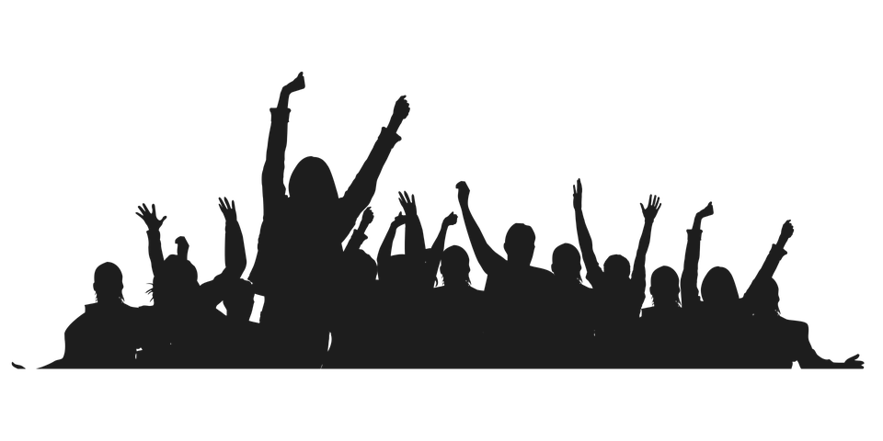
- MCCOY is recognized as central Indiana’s coordinating hub for youth well-being and equity verified by bi-annual environment survey.

Environment and Situation for Children in Marion County
Summary of Community Needs
Marion County’s ~240,000 children confront a complex reality. While progress has been made — child poverty is decreasing, and graduation rates are rising — deep inequities remain. One in five children live in poverty, and many attend underperforming schools. The mental health crisis is stark: over 30% of youth report sustained feelings of sadness or hopelessness, and nearly 1 in 4 children have experienced a mental, behavioral, or developmental challenge. Environmental and neighborhood conditions — vacant properties, limited safe spaces, perceptions of unsafe communities — further burden children’s capacity to thrive. To build equitable futures, we must focus efforts on mental health, academic achievement, family stability, and neighborhood revitalization. Only by layering support -- across classrooms, community-based services, health clinics, and at home — can we shift trajectories for children across Marion County.
1. Overview & Context
- Indiana ranks 27th nationally for overall child well-being (amongst states) highlighting that, even as some statewide indicators improve, significant equity gaps remain. Indiana Youth Institute, Indiana Capital Chronicle
- Marion County has a relatively high Child Dependency Ratio (ratio of the number of children under the age of 15 divided by the number of people ages 15 to 64.)
- Marion County’s children are on average younger than the state overall, and more racially diverse with children of color representing over half of the county’s children, which has implications for equity efforts. U.S. Census
- Over 30% of county schools are classified as underperforming Indiana Youth Institute
- Approximate half of Indianapolis’ justice involved youth are dual status ranking among the highest in the country. These youth are more likely to suffer a host of problems – higher recidivism, higher rates of academic failure, mental problems, and substance abuse. The evidence is clear: mental health challenges are a driving force behind violence and crime. Administration for Children and Family (ACF)
- Marion County, as a densely populated urban county that includes Indianapolis, reflects many of the pressures of urban life: concentrated poverty, disparities in access to services, and stressors around mental health, education, and neighborhood safety.

2. Key “Dimensions of Well-Being”: Strengths & Challenges
Below is a dimension-by-dimension summary of what the data suggests for children in Marion County.
Dimension | Strengths / Positive Trends | Challenges / Gaps | Implications
Economic Stability | - Some decline in child poverty: reports suggest Marion County’s child poverty has dropped from nearly 30% (2017) to ~21% (2023) although still higher than Indiana overall at 15.1% STATS Indiana  - Some increases in health insurance coverage across Indiana, which can buffer health risks while CHIP and ACA programs remain in place | - One in five children under age 18 in Marion County is estimated to live in poverty (21% per Census data) which is above the state average of ~16% and the national average of 11%. (US Census Bureau)  - Many families face high housing cost burdens, food insecurity, and unstable housing (homelessness or housing instability) Where the Children Are  - Income inequality and racial disparities remain stark (Black, Latino, and immigrant families more likely to experience economic hardship) US Census | - Economic stress at the family level undermines children’s ability to focus on school, maintain stability, and access enrichment opportunities  - Need for stronger policies and programs offering rental assistance, food supports, employment pathways, and school-based wraparound services
Education & School Performance | - Graduation rates in Marion County have risen (recent reports cite ~83%) Fairbanks Foundation  - IREAD – 3 scores rose to 79% in 2025 up froma low of 70% in 2021 but still trailing the 2013 high of 85%. | - Over 30% of county schools are classified as underperforming and 70 schools experience <10% pass rate on I LEARN tests (IYI)  - Chronic absenteeism, learning loss post-COVID, and lack of early childhood (pre-K) access are serious barriers  - Disparities by race/ZIP code: students in lower-resourced neighborhoods face compounded barriers (fewer supports, less stable environments)  - Only 40% of Indiana’s children aged 3-4 are enrolled in an early education program, well below the national average. US Census Bureau | - Without investment in tutoring, summer learning, early childhood programs, and school support (e.g. counselors, enrichment), gaps will widen  - Place-based strategies (targeting neighborhoods of need) will be more effective than blanket approaches  - Partnerships between schools, community orgs, and families are critical to close opportunity gaps
Health, Safety, Mental Health & Behavioral Well-Being | - Some positive trends in substance use: reports suggest declines in teen use of alcohol, tobacco, and other substances in Marion County. IYI- Access to exercise opportunities is relatively strong locally: Marion County reportedly has ~91% access (versus ~76% statewide) Mirror Indy | The mental health crisis is acute: in Marion County, over 30% of youth report feeling sad or hopeless for at least two weeks, which is well beyond normal mood fluctuations. (IYI) In 2024, nearly one-third of Hoosier high schoolers reported feeling sad or hopeless almost every day in a two-week period, and 1 in 7 seriously considered suicide.  - The Community Mental Health Needs Assessment (2023) found that ~28.2% of children ages 3–17 have one or more mental, emotional, developmental, or behavioral (MEDB) problems; ~14.2% have two or more. fairbanks.indianapolis.iu.edu  - In Marion County, among children aged 5–17, ~10% were reported to have been diagnosed with depression or anxiety; ADHD/ADD is also high (~16%); asthma diagnoses (~20%) exceed national rates. marionhealth.org  Suicide rates among Black youth ages 10–17 rose 144% between 2007 and 2020, yet Black adolescents remain significantly less likely to receive mental health care (Pew Charitable Trusts).  One of the strongest predictors of future mental health challenges is exposure to Adverse Childhood Experiences (ACEs) which include abuse, neglect, parental incarceration, substance use, and exposure to violence. National research consistently shows that the more ACEs a child experiences, the higher their risk for serious mental health issues. In Indiana, more than 17% of Hoosier children reported at least two ACEs, placing the state 32nd nationally. | - Mental health services in schools and community are overburdened; many children needing care may go untreated  - A National Institute of Health (NIH) study shows a clear correlation between mental wellbeing and outcomes across health, risk behaviors, education, decision-making, and crime. Specifically, “the presence of any (mental health) disorder was associated with 4 to 5 times increased risk of crime outcomes.”  - Integration of mental health and primary care in schools is critical  - Efforts to strengthen neighborhood safety, reduce environmental stressors, and promote trauma-informed practices will support resilience  - Preventive health and health education should be prioritized  The evidence is clear: mental health challenges—often rooted in traumatic childhood experiences—are a driving force behind violence and crime. This cycle is complex, multi-generational, and deeply damaging, but it is also interruptible. The Resilience Project is designed to do exactly that: build systems of support that foster resilience, wellness, and safety for Indiana’s youth.
Family, Community & Neighborhood Context | - Some improvements in family & community indicators reported statewide: fewer children living in concentrated poverty zones, higher caregiver educational attainment in some cases. Indiana Youth Institute | - Many children grow up in neighborhoods lacking adequate amenities: parks, libraries, safe recreation centers, sidewalks — factors known to support healthy development  - Neighborhood disorder (vacant properties, blight) and perceived lack of safety add stress to families  - Disconnection, social isolation, and lack of community cohesion are often more intense in under-resourced ZIP codes  - Housing instability & high rent burdens threaten continuity for children  - Approximate half of Indianapolis’ justice involved youth are dual status ranking among the highest in the country. These youth are more likely to suffer a host of problems – higher recidivism, higher rates of academic failure, mental problems, and substance abuse. The evidence is clear: mental health challenges are a driving force behind violence and crime. Administration for Children and Family (ACF) | - Community investment (green space, safe play areas, youth centers) and neighborhood revitalization are needed  - Strengthening social cohesion can buffer adverse conditions  - Family support services (parent education, mental health for caregivers, economic supports) are essential complements to child-focused interventions

3. Needs Assessment through the lens of the Community
Source: survey of organizations and youth-service workers across Marion County, May 2025
Top Needs Facing Youth
- Mental wellness and access to trauma-informed care
- Violence prevention and conflict resolution skills
- Engagement opportunities in community programs and activities
- Career readiness and life skills development
Top Issues Facing Youth-Serving Organizations
- Limited resources: funding and staffing shortages
- Workforce challenges: effectiveness, recruitment, and retention
- Legislative constraints: DEIB-related restrictions, immigration, funding limitations
- Staff satisfaction and leadership support
- Difficulty navigating systems of care -- Understanding legal rights and system access.
Top Issues Facing Youth-Serving Employees
- Career growth barriers and limited advancement opportunities
- Mental health stress and burnout
- Need for training in:
  - Mental health support and trauma-informed care
  - Cultural competency and youth engagement strategies
  - Time management and leadership skills

Overall, the data highlights urgent needs for mental health support, workforce capacity building, stronger leadership, and more sustainable funding across youth-serving systems.
- The Network of Youth Service Support

MCCOY’s Distinct Role Among Intermediary Organizations
Indiana is home to several intermediary organizations dedicated to supporting youth and the professionals who serve them, including Indiana Youth Institute (IYI), Indiana AfterSchool Network (IAN), EmployIndy, Indiana Association of Resources and Child Advocacy (IARCA), and the Indiana Youth Services Association (IYSA). While each organization contributes meaningfully to the wellbeing of young people, MCCOY occupies a distinct and complementary role within this ecosystem.

Organization | What They Do | What Makes MCCOY Different
Indiana Youth Institute (IYI) | Supports youth services through training, critical data, and capacity-building resources. | MCCOY delivers comprehensive support—advocacy, education, research, training, and development—focused specifically in Marion County.
Indiana AfterSchool Network (IAN) | Support out-of-school time programs and professionals across Indiana. | MCCOY promotes full youth engagement year-round, not limited to afterschool settings, and serves only Marion County.
EmployIndy | Prepares young adults for the workforce. | MCCOY supports holistic youth development—beyond job readiness—to strengthen the full ecosystem of youth services.
Indiana Association of Resources and Child Advocacy (IARCA) | Represents approximately 100 member agencies in Indiana providing a broad array of services, including residential care, foster care, transitional/independent living, home-based services, shelter care, and crisis stabilization. | MCCOY supports the entire community of youth-serving organizations in Marion County; we advocate for systems change, not contracts or lobbying.
Indiana Youth Services Association (IYSA) | Statewide association of Youth Service Bureaus (YSBs) across Indiana. IYSA also operates several programs that support youth, youth workers, and other non-profit agencies. Youth Service Bureaus deliver community based juvenile delinquency and family support programming. IYSA’s current 26 members serve approximately 65 Hoosier counties. | MCCOY serves all youth-serving organizations and all children in Marion County – not a specific segment nor are we a membership model

Like IYI, IAN, and IYSA, MCCOY provides training, professional development, and coordination to strengthen the capacity of youth-serving programs. However, where these organizations work statewide or within specific sectors—such as afterschool programming, child welfare, or juvenile justice, MCCOY’s focus is intentionally place-based and comprehensive, centering exclusively on Marion County and encompassing all facets of youth development.
Unlike EmployIndy, whose mission is tied to workforce readiness, MCCOY’s approach spans a broader continuum of youth wellbeing, including education, mental health, leadership, safety, and family stability. Similarly, while IARCA and IYSA operate as membership or contract-based associations for specific types of agencies, MCCOY does not represent a single constituency. Instead, MCCOY serves as a neutral convener and advocates for systems change, strengthening collaboration among diverse organizations to improve conditions and outcomes for all young people in the county.
In essence, MCCOY’s difference lies in its comprehensive, county-centered, and cross-sector focus. By combining advocacy, education, research, and coalition-building under one roof, MCCOY uniquely bridges the work of multiple intermediary organizations—serving as Marion County’s coordinating hub for youth development and wellbeing.
- MCCOY – Where We Are Today
  - Strengths/Weaknesses/Opportunities/Threats
Source: Survey of staff and board members, synthesized by ad hoc committee

MCCOY stands on a foundation of more than 30 years of goodwill, credibility, and trusted relationships throughout the community. The organization benefits from a clear and shared mission, informed by a deep understanding of youth challenges and a system-level perspective that connects programs, policy, and partnerships. MCCOY’s strong and diverse team is cultivating an increasingly collaborative culture, and its programs are now more integrated and strategically aligned than ever before. Operationally, MCCOY is stable and consistent, with a measurable record of community impact and influence. Its funding base, largely independent of state and federal sources, provides flexibility and preserves mission integrity. The organization’s nimble, adaptive nature allows it to respond quickly to emerging youth needs, while recent initiatives—such as gun safety efforts, Youth Day at the Statehouse, and youth leadership programs—have elevated MCCOY’s visibility with media and corporate partners.

At the same time, MCCOY operates under constraints that limit its ability to meet the full scale of community needs. Staffing remains lean for the breadth of work expected, and there is a continuing need for individual professional development opportunities. While financial support is strong, funding diversity is narrow, leaving the organization vulnerable to shifts in philanthropic priorities. The lack of a dedicated development professional and limited unrestricted dollars further constrain growth. Program integration, though improving, still requires deeper alignment to maximize mission impact, and overall brand awareness remains uneven across the community.

Looking ahead, MCCOY has significant opportunities to strengthen its system-level leadership as the voice for youth in Central Indiana. There is potential to expand its visibility and credibility across media, policymaking, and corporate sectors; to convene community partners around priority issues such as youth mental health; and to position itself as a leading source of data, insight, and education for youth-serving organizations and decision-makers. By nurturing staff innovation, continuous learning, and authentic youth engagement, MCCOY can continue to build momentum and relevance in a rapidly changing environment.

However, external threats remain. Chronic under-resourcing across the youth-serving ecosystem increases the risk of staff burnout and turnover. At the same time, shrinking government funding streams and heightened competition for private dollars pose long-term sustainability challenges. Political polarization and policy restrictions, particularly around diversity, equity, inclusion, and belonging (DEIB) and immigration, could further constrain public funding and program partnerships. These dynamics reinforce the urgency for MCCOY to continue diversifying resources, strengthening partnerships, and asserting its leadership in advocacy and collaboration to safeguard the wellbeing of Central Indiana’s youth.

S.W.O.T. Detail
Strengths  - More than 30 years of goodwill, credibility, and trusted community relationships.  - Clear, shared organizational mission.  - Deep understanding of youth challenges, supported by a systems-level focus.  - Strong, diverse team with a growing collaborative culture.  - Programs are more integrated and aligned across teams than ever before.  - Consistent, stable operations with measurable community impact and influence.  - Strong funding base that is independent of state and federal sources.  - Nimble and adaptive organization, responsive to emerging youth needs.  - Recent initiatives—such as gun safety, Youth Day at the Statehouse, and youth leadership programs—have elevated MCCOY’s visibility and reputation with media and corporate partners. | Weaknesses  - Under-resourced for the scale of work required, especially in staffing.  - Need for more individual professional development opportunities.  - Funding, while solid, remains insufficient to meet community needs.  - Narrow funding diversity creates financial vulnerability.  - Lack of a dedicated development director and limited unrestricted funding.  - Continued need to deepen program integration for greater mission impact.  - Brand awareness remains uneven—many community members do not fully understand MCCOY’s intermediary role or how to engage with us.
Opportunities  - Strengthen MCCOY’s system-level leadership and position as the voice for youth in Central Indiana.  - Expand visibility and credibility in media, policymaking, and corporate spaces.  - Establish MCCOY as a go-to community resource for funders, businesses, and civic leaders.  - Expand convening around specific priority topics, for example, a Marion County Youth Mental Health Roundtable with schools, providers, youth, and families to align efforts and share data.  - Become a leading source for data, insight, and education for youth-serving organizations, decision-makers, and policy makers.  - Encourage staff innovation and continuous learning.  - Expand opportunities for meaningful youth engagement in community initiatives. | Threats  - Chronic under-resourcing—both within MCCOY and the broader youth-serving ecosystem—risks staff burnout and turnover.  - Shrinking federal and state funding streams; increasing competition for private dollars.  - Limited access to federal or state funding without compromising organizational independence or mission integrity.  - Political polarization and policy barriers, particularly around DEIB, immigration, and public funding.

The MCCOY Team
Contracted roles
Accounting/Audit
Donovan CPAs

The Marion County Commission on Youth (MCCOY) is led by a skilled and deeply committed team whose collective expertise spans education, policy, communications, and nonprofit leadership. Together, they drive the organization’s mission to champion youth success through collaboration, advocacy, and capacity building.

Elizabeth (Liz) Coit (she/her) serves as MCCOY’s President, overseeing strategic direction, organizational planning, and innovation. A results-oriented leader, Liz brings extensive academic and professional credentials, including an undergraduate degree from Occidental College, an MBA from Harvard Business School, and nonprofit leadership certificates from both Harvard University and the IU School of Philanthropy. Her leadership ensures that MCCOY’s programs achieve measurable outcomes aligned with the organization’s mission and goals.
Ciera Banks (she/her), Assistant Program Manager, provides operational and communications support across MCCOY’s training and development programs. A graduate of Eastern Michigan University with a bachelor’s degree in communication, Ciera ensures effective coordination and delivery of program logistics.
DJ Cleveland (they/she), Director of Marketing and Communication, leads MCCOY’s strategic communications, public relations, and social media initiatives. DJ holds a B.A. in Telecommunications Design and Production from Indiana University and an M.A. in Public Relations from Ball State University and applies both creativity and strategy to amplify MCCOY’s message and impact.
LaMarr Davis II (he/him), Program Director, oversees MCCOY’s Mayor’s Youth Leadership Council and provides strategic guidance for the Juvenile Advisory Council. His leadership strengthens youth voice and engagement in civic initiatives across Marion County.
Fletcher Eliot (they/he), Director of Training and Development, is an experienced educator, facilitator, and youth development specialist with more than a decade of experience. Fletcher leads several of MCCOY’s signature programs—including The Resilience Project and To Rise Above Poverty—where they design curriculum, deliver training, and mentor participants. They hold a bachelor’s degree from Indiana University and a master’s degree in education from IUPUI.
Lauren George (she/her), Assistant Advocacy Manager, supports the advancement of MCCOY’s public policy initiatives, deepening the organization’s engagement and influence. Lauren holds a Master of Education in Early Childhood Education from Ball State University and a Bachelor of Science in Early Childhood Education from Purdue University.
Sarah Kumfer (she/her), Director of Advocacy and Public Policy, guides MCCOY’s advocacy agenda and government relations. Since joining MCCOY in 2019, she has leveraged her experience in Washington, D.C.—including roles with U.S. Senator Joe Donnelly and the Meridian International Center—to strengthen local and state advocacy for youth. Sarah earned her master’s degree in Global Advocacy from The George Washington University and her bachelor’s degree in political science and Spanish from Indiana University. She is fluent in Spanish.
Amanda McGhee (she/her), Executive Assistant, manages MCCOY’s administrative and operational functions with precision and efficiency. A graduate of Indiana University, Amanda ensures seamless coordination across the organization and provides vital support to all programmatic and executive efforts.

MCCOY supplements its in-house expertise with strategic professional partners. Human resources functions are managed through WorkSmart, a Professional Employment Organization; financial reporting and bookkeeping are managed by Foster Results; tax reporting and audit are contracted to Donovan CPAs; and professional grant writing services are provided by Toby Stark, who collaborates closely with the President on annual grant submissions.

MCCOY’s work is further strengthened by its Board of Directors, a diverse and experienced body of leaders representing education, healthcare, justice, corporate, and nonprofit sectors. The Board provides governance, oversight, and community insight—ensuring MCCOY’s continued accountability and alignment with the needs of Marion County’s youth.

As MCCOY continues to grow and expand its impact, strategic consideration needs to be given to deepening organizational capacity—particularly by adding depth to the marketing and communications team and securing a full-time development professional with extensive experience in grant writing and relationship cultivation. These enhancements will ensure MCCOY’s continued ability to sustain, scale, and strengthen programs that serve the community.

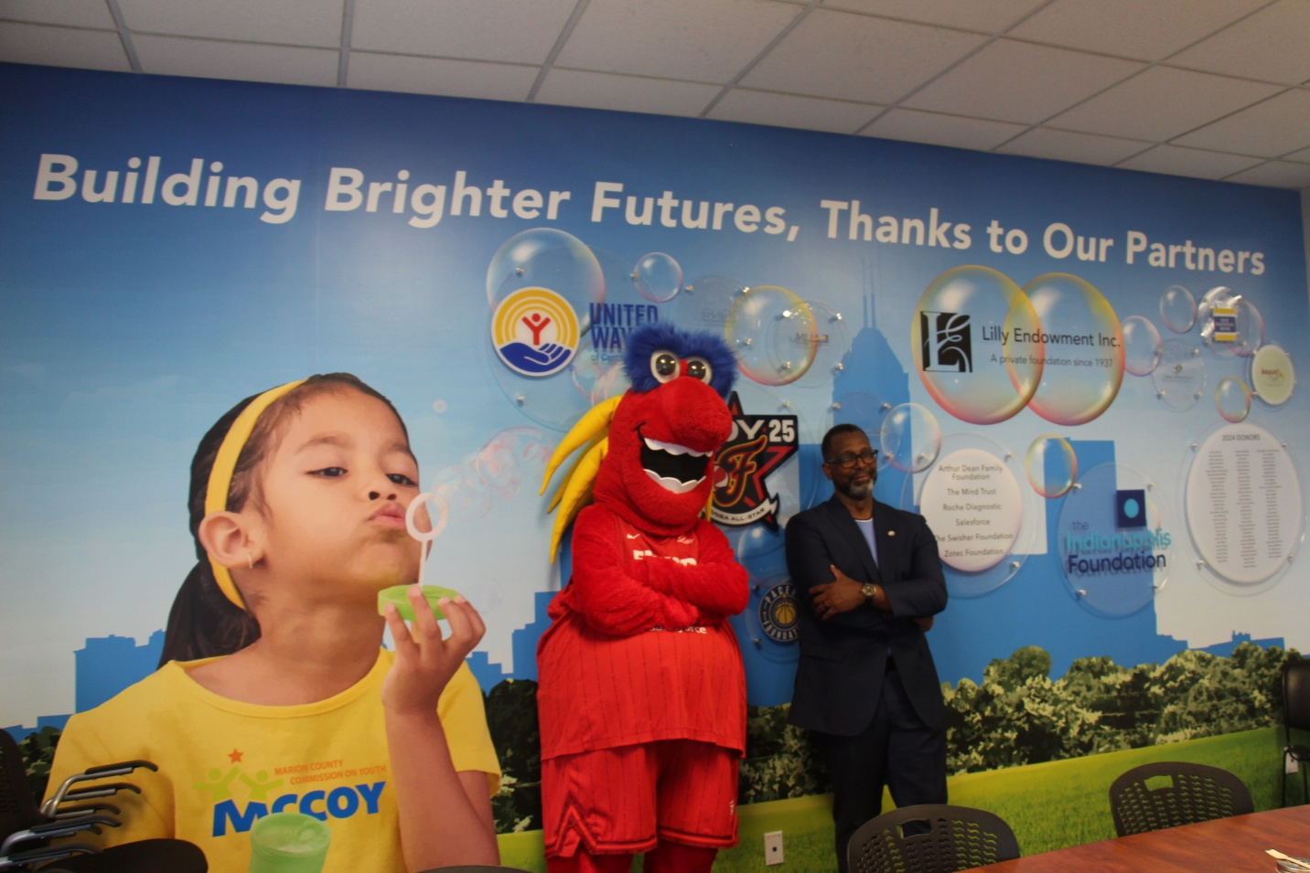

Statement of Financial Position
Audited Financial
Assets | 2024 | 2023
Cash | $1,462,764 | $1,371,291
Accounts Receivable | 106,499 | 36,515
Right of use Assets | 225,348 | 183,586
Other | 13,177 | 17,971
Total Assets | 1,807,788 | 1,609,363
Liabilities | 2024 | 2023
Deferred Revenue | 619,083 | 600,342
Lease Liability | 175,746 | 135,754
Other Liabilities | 67,927 | 60,185
Total Liabilities | 862,756 | 796,281
Total Equity | 945,032 | 813,082
Total Liabilities & Equity | 1,807,788 | 1,609,363
  - MCCOY’s Financial Position
MCCOY’s financial position remains strong, with reserves equal to approximately eight months of operating expenses. In 2025, our balance sheet was further strengthened through significant capital investment in our leased office space. A combined $520,000 in grants from two funding sources enabled us to complete a full renovation of our outdated office and to replace aging computer and technology equipment during the first half of the year. This investment ensures that MCCOY’s physical and operational infrastructure are well-positioned to support our growing programs and strategic initiatives in the years ahead.

Our funding sources remain highly concentrated with a few large grantors dominating. The following chart represents our current funding mix:

Our current grant sources include:

MCCOY continues to strengthen and diversify its funding sources to reduce reliance on any single contributor and ensure continued compliance with IRS public support test requirements. In 2023 and 2024, the organization’s public support test results were 35.47% and 36.73% respectively.

To further enhance fiscal stewardship and accountability, MCCOY’s Board approved two key governance documents in 2025: a Gift Acceptance Policy, which ensures that all contributions align with MCCOY’s mission, values, and donor intent; and a Financial Policies and Procedures Manual, which establishes clear standards for financial reporting, transactions, and audit practices.

Summary of Needs and Priorities
Children in Marion County face a complex mix of progress and persistent inequities. While poverty and graduation rates are improving, one in four children still live in poverty, and mental health challenges are at crisis levels. Many neighborhoods remain unsafe or under-resourced, limiting young people’s ability to learn, grow, and thrive. To achieve equity, Marion County must layer support across schools, families, and communities.

Every child’s future is shaped not only by family and school, but by the strength of their community.

Key Dimensions of Wellbeing
Economic Stability
- Child poverty has declined from nearly 29% to about 21%, yet Black, Latino, and immigrant families remain disproportionately affected.
- Housing instability, food insecurity, and high-cost burdens undermine family well-being.
- Need: Expand family supports — rental aid, food access, employment pathways, and wraparound school services.
Education
- Graduation rates (~82%) are rising, but 30% of schools remain underperforming.
- Post-pandemic learning loss, chronic absenteeism, and lack of early learning access persist.
- Need: Invest in early childhood education, tutoring, counseling, and neighborhood-based academic support.

Health & Mental Health
- Over 30% of youth report persistent sadness or hopelessness; nearly 1 in 4 faces a mental, emotional, or behavioral challenge.
- Chronic conditions (asthma, dental issues) and overburdened care systems compound risks.
- Need: Integrate mental health and primary care in schools; expand trauma-informed, preventive health supports.
Family & Community
- Neighborhood disinvestment, unsafe spaces, and lack of youth-friendly infrastructure heighten family stress.
- Need: Revitalize neighborhoods, expand safe recreation, and strengthen family and social support.
Community Voice: 2025 Needs Assessment
Top Youth Needs:
• Mental wellness & trauma-informed care
• Violence prevention & conflict resolution
• Community engagement opportunities
• Career readiness & life skills development
Top Organizational Challenges:
• Funding and staffing shortages
• Policy barriers (DEIB restrictions, limited resources)
• Burnout and workforce turnover
MCCOY’s Distinct Role
Among Indiana’s youth-focused intermediary organizations, MCCOY stands out as the only entity dedicated exclusively to Marion County, bridging the fields of education, health, advocacy, and family systems to improve outcomes for all young people.
- Neutral Convener: Brings together schools, nonprofits, policymakers, and funders to align efforts and resources.
- Systems-Level Leader: Advances policies and practices that strengthen the full ecosystem of youth services through advocacy, capacity building, and data-informed collaboration.
- Equity Champion: Works to ensure that every child in Marion County has access to opportunity and support—regardless of their neighborhood or circumstances.
MCCOY serves as Marion County’s coordinating hub for youth development and wellbeing.
Organizational Investment Needs
To sustain and expand this impact, MCCOY’s operations would be significantly enhanced by:
- Expanded staffing capacity, particularly in fundraising and marketing, to strengthen organizational visibility and sustainability.
- Continued diversification of funding sources to reduce dependency on a small group of grantors and ensure long-term fiscal resilience.
- Larger source of unrestricted funding to support the continuity of programs initiated through restricted grants and allow for continued investment in systems-level impact not readily funded through restricted funding.

MCCOY’s Strategic Framework -- Pillars and Priorities

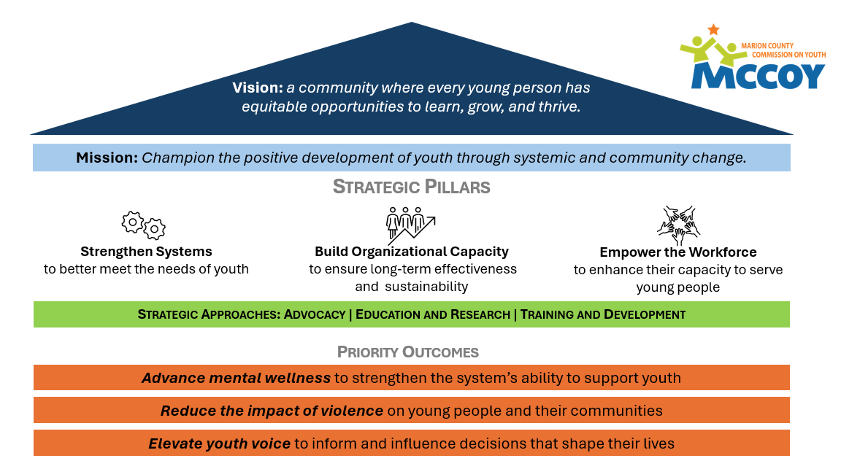
Marion County Commission on Youth’s (MCCOY’s) strategic framework connects its vision, mission, and core strategies to drive measurable improvements in youth outcomes across Marion County. MCCOY’s vision is a community where every young person has equitable opportunities to learn, grow, and thrive. Its mission captures the organization’s purpose: to champion the positive development of youth through systemic and community change. Rather than serving youth directly, MCCOY strengthens the systems, organizations, and professionals that serve them.

Strategic Pillars
The framework is anchored by three pillars that guide MCCOY’s work:
- Strengthen Systems
Improve coordination and effectiveness across the youth-serving ecosystem to better meet young people’s needs.
- Build Organizational Capacity
Equip agencies with the tools, training, and partnerships required for long-term effectiveness and sustainability.
- Empower the Workforce
Enhance the capacity of professionals who serve youth through training, professional development, and continuous support.

Strategic Approaches
MCCOY achieves its mission through three interrelated approaches:
- Advocacy
Drives systemic change by shaping public policy, building coalitions, and equipping community leaders with data and insight to improve outcomes for youth.
- Education & Research
Strengthens community understanding through data dissemination, awareness campaigns, and convenings that spotlight the issues facing children and youth in Marion County. These efforts create shared understanding and inform collective action.
  - Training & Development
Builds and strengthens capacity across the youth ecosystem through professional development, technical assistance, and strategic partnerships. MCCOY also achieves this by investing in creating innovative approaches breaking perceived barriers to progress.
—ultimately improving the effectiveness of youth-serving organizations.

Priority Outcomes
Grounded in current community needs, MCCOY’s strategic framework prioritizes three outcomes to create lasting change across Marion County:
- Advance Mental Wellness – Strengthen community capacity to support youth mental health and resilience.
- Reduce the Impact of Violence – Support safe, connected neighborhoods and reduce youth exposure to trauma.
- Elevate Youth Voice – Empower young people to help shape the decisions that affect their lives through programs like the Mayor’s Youth Leadership Council and Fever Confidence. Youth engagement ensures young people are both served and heard.

Summary
MCCOY’s strategic framework translates mission into measurable, community-level impact—linking vision to strategy to outcomes. By aligning systems, empowering professionals, and amplifying youth voice, MCCOY builds a stronger, more supportive environment for every child in Marion County.

- MCCOY’s Current Programs Alignment with the Framework
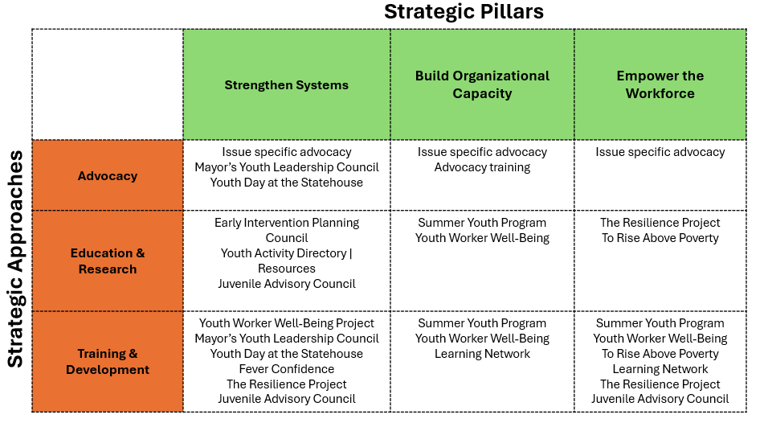

Current Program Alignment
MCCOY’s current programs align strongly with our mission to champion the positive development of youth in Marion County by supporting, connecting, and amplifying the work of organizations that serve them. Each program contributes to a key pillar of our strategic framework: Strengthening Systems; Building Organizational Capacity; Empowering the Workforce. And each engages one or more of MCCOY’s three strategic approaches: Advocacy; Education & Research; Training & Development. Foundational programs from this chart include the following:

  - Summer Youth Program (SYP)
Each year, MCCOY provides technical and capacity-building support to more than 260 summer youth programs across Marion County in alignment with the strategies and investments of the Summer Youth Program Fund (SYPF). This work ensures that thousands of young people have access to safe, engaging, and enriching summer experiences that promote learning, growth, and connection.

MCCOY’s role is to strengthen and connect the network of summer programs so that every organization—regardless of size or budget—has the tools, knowledge, and community relationships needed to deliver high-quality youth experiences. Through communication, coordination, and training, MCCOY helps build a sustainable, collaborative ecosystem of summer learning providers.

  - The Resilience Project
MCCOY’s school-based mental wellness initiative is designed to build emotional resilience, strengthen educator capacity, and create supportive learning environments for children. Developed in partnership with local school districts, the program equips teachers and staff with the knowledge, tools, and confidence to recognize and respond to students’ mental health needs while also caring for their own wellbeing. Intended outcomes include
- Increased educator understanding of mental health and resilience.
- Improved school climate and teacher-student relationships.
- Reduced stress and burnout among teachers.
- Greater student engagement, self-regulation, and connectedness.
- Stronger family-school-child connections to support youth resilience.

  - Youth Worker Well-being Project (YWWB)
MCCOY along with the four other intermediaries serving youth organizations in Indiana (Indiana Youth Institute, Indiana Afterschool Network, Indiana Youth Services Association, and Indiana Association of Resources and Child Advocacy) created and are implementing the YWWB initiative. The program is designed to strengthen the mental health, resilience, and professional sustainability of the adults who serve young people across Marion County. Recognizing that youth workers are the backbone of the youth development ecosystem—and that their own wellbeing directly affects program quality and youth outcomes—the five managing committee members designed this project to provide both immediate supports and long-term system improvements.

  - Learning Network
MCCOY provides a comprehensive menu of professional development opportunities for youth-serving professionals across Marion County. Our training portfolio includes topics such as diversity, equity, and belonging; mental well-being; and trauma-informed care, among others. Each year, hundreds of participants engage in these sessions—either through stand-alone workshops or as part of the Summer Youth Program. Training offered to the wider community is provided free of charge, while customized sessions for individual organizations are available for a modest fee.
  - To Rise Above Poverty (T.R.A.P.)
The To Rise Above Poverty (T.R.A.P.) initiative is a pilot program currently underway at three Glick Family residential properties in Indianapolis. T.R.A.P. is designed to confront two-generational poverty by strengthening the capacity of community leaders who work most closely with families in need. In this pilot, the program equips resident coordinators with the tools and training necessary to assess community needs, design effective programming, and implement supports that engage both youth and their caregivers.
Through a focus on leadership development and systems change, T.R.A.P. builds a foundation of practical skills and shared purpose among those working on the front lines of poverty. The program promotes strategies that address the root causes of sustained poverty—including mental wellness, access to support resources, and the development of new mindsets and behaviors that lead to long-term stability and independence.

By empowering local leaders and embedding change within the communities they serve, T.R.A.P. aims to create a sustainable pathway out of poverty that uplifts families across generations and strengthens the broader ecosystem of community support.

  - Advocacy and Youth Voice
MCCOY’s Advocacy program amplifies the needs of young people and those who serve them, ensuring that these needs and perspectives shape public policy, community priorities, and systems change across Central Indiana. Through research, coalition-building, and direct engagement with policymakers, MCCOY advocates for equitable opportunities, safe environments, and supportive systems that help all young people thrive. The organization serves as a trusted convener and resource, bridging the gap between youth-serving organizations, families, and decision-makers to create meaningful and lasting impact.

One of MCCOY’s signature advocacy initiatives, Youth Day at the Statehouse, empowers young people to experience civic engagement firsthand. This annual event brings together hundreds of youths from across Marion County and beyond to meet with legislators, learn about the policymaking process, and practice civic leadership. Youth Day provides a powerful platform for students to express their views on issues that affect them—ranging from education and safety to mental health and equity—while helping policymakers better understand the realities and aspirations of Indiana’s young people.

Complementing these efforts, MCCOY’s SoundOff Newsletter keeps the community informed and connected on key youth policy issues. Distributed regularly to a broad network of partners, stakeholders, and advocates, SoundOff shares legislative updates, policy analysis, and opportunities for engagement. It serves as both an educational resource and a call to action—encouraging readers to stay informed, get involved, and raise their voices in support of youth-centered policy change.

Early Intervention Planning Council (EIPC)
A collaborative body coordinated by MCCOY eliminate child abuse, neglect and involvement with the legal system by coordinating efforts that increased availability and access to services and advocates for high quality early intervention and prevention services in Marion County. Established by city ordinance in 2005, the Council brings together community leaders, justice professionals, educators, service providers, and residents to understand the situation for youth, root causes, and to recommend strategies for early, community-based intervention.

Mayor’s Youth Leadership Council (MYLC)
One of MCCOY’s signature youth engagement initiatives, designed to amplify youth voice and prepare young people to be active, informed leaders in their communities. Established in partnership with the City of Indianapolis, the MYLC brings together high school students from across Marion County to advise city officials, build leadership skills, and address issues impacting youth and families.

Juvenile Advisory Council (JAC)
A new young adult-led initiative coordinated by MCCOY that empowers young people with lived experience in the juvenile justice system to inform, advise, and improve local youth justice practices. The Council provides a structured platform for youth voices to influence policies and programs affecting them—promoting equity, accountability, and meaningful system reform across Marion County.

Together, these efforts strengthen MCCOY’s role as a leading advocate and connector, advancing a unified voice for youth across Central Indiana. Each of MCCOY’s programs—The Resilience Project, Advocacy, T.R.A.P., Youth Worker Well-Being Project, Mayor’s Youth Leadership Council, Juvenile Advisory Council, Early Intervention Planning Council, and Summer Youth Program, among others—serves as a vital building block in advancing our strategic pillars and fulfilling our mission. Together, these initiatives strengthen systems, build organizational capacity, and empower the workforce that supports youth across Marion County.

MCCOY’s challenge over the next three to five years is to invest strategically—expanding and deepening program reach and impact while maintaining excellence and sustainability. The following assessment outlines opportunities for program growth, innovation, and alignment with our long-term vision for a stronger, more equitable ecosystem of youth support.

- Program Growth and Development Assessment (2026–2030)
Over the next five years, MCCOY is poised to deepen its role as the backbone organization for Marion County’s youth-serving ecosystem—strengthening systems, building capacity, and empowering the workforce that supports youth. Guided by our strategic pillars, this plan focuses on scaling impact, fostering innovation, and ensuring sustainability across MCCOY’s programs and partnerships.

Our growth strategy emphasizes integration and alignment—leveraging data, relationships, and shared learning to ensure that every initiative reinforces the whole. MCCOY’s programs collectively aim to address the most pressing challenges facing young people today: mental health and resilience, economic mobility, civic engagement, and safety.

1. Summer Youth Program Fund Support
Focus: Capacity-building and coordination for summer youth programs
MCCOY will continue to lead coordination for more than 260 summer youth programs across Marion County, ensuring equitable access to high-quality, enriching summer experiences for thousands of young people. Building on a decade of trusted leadership, MCCOY will expand its Summer Youth Program support through:
- Establishing a Summer Learning Community to foster peer collaboration and innovation among program leaders.
- Launching the youth-service career development pathway, supported by digital badge certification program to strengthen the youth-serving workforce.
- Expanding data collection and evaluation capacity to track participation, quality, and outcomes across the network.
- Enhancing family access and public visibility through MCCOY’s FindHelp-based directory and coordinated marketing campaigns, resulting in increased engagement and utilization.
- Integrating Youth Worker Well-being principles into summer training to promote staff sustainability and retention.
- Integrating SEL tools and training from the Resilience Project adapted for summer learning and experiences.
Strategic Alignment: Build Organizational Capacity | Strengthen Systems | Empower the Workforce

2. The Resilience Project
Focus: School-based mental health and educator resilience
By 2030, MCCOY hopes to grow the Resilience Project from a township-based pilot to a countywide initiative supporting teachers, staff, and students across Marion County. Key development areas include:
- Scaling to additional school districts through blended in-person and digital training models.
- Establishing a Resilience Network of trained educators who serve as trainers, peer mentors, and advocates.
- Strengthening data and evaluation systems to document improvements in school climate, teacher wellbeing, and student engagement.
- Securing long-term investment partnerships to sustain curriculum development and coaching support.
Strategic Alignment: Empower the Workforce | Strengthen Systems

3. Youth Worker Well-Being Project
Focus: Supporting the mental health and sustainability of youth-serving professionals
As a founding partner in the statewide youth intermediary coalition, MCCOY will continue advancing workforce wellness as a cornerstone of youth development. Over the next five years, growth priorities specific to MCCOY and in support of the bigger YWWB initiative include:
- Expanding participation among Marion County organizations and embedding wellness supports in all technical assistance services.
- Advocating for workforce wellness as a funded requirement in public and philanthropic grants, as well as within city and state budgets.
- Building a repository of best practices and case studies to influence standards for youth worker care and sustainability across the Marion County network of youth-serving organizations.
Strategic Alignment: Empower the Workforce | Build Organizational Capacity | Strengthen Systems

  - Learning Network
Focus: MCCOY’s Learning Network provides a foundation of professional development designed to strengthen the skills and knowledge of youth-service professionals across Marion County. The initiative focuses on creating structured learning pathways in high-priority areas such as mental well-being, trauma-informed care, and project management, among others.
Over the next five years, MCCOY will expand and deepen this effort by:
- Developing defined training tracks that allow participants to build skills progressively and specialize in key areas of practice.
- Introducing a recognition system—such as a digital badge program—to acknowledge individual achievement and sustained engagement within the Learning Network.
- Implementing a robust evaluation framework to monitor participant progress and assess the overall effectiveness of the program in strengthening the youth-services workforce.
Strategic Alignment: Empower the Workforce | Build Organizational Capacity | Strengthen Systems

  - To Rise Above Poverty (T.R.A.P.)
Focus: Breaking two-generational poverty through community leadership development
Following the success of its pilot at three Glick Family properties, MCCOY, in collaboration with Glick leadership, aims to expand T.R.A.P. into additional neighborhoods and partner sites. Future growth will include:
- Training new cohorts of resident coordinators and community leaders.
- Establishing shared learning networks across participating communities.
- Integrating mental wellness, financial literacy, and family empowerment programming.
- Measuring longitudinal outcomes for families progressing toward economic stability.
Strategic Alignment: Strengthen Systems | Build Organizational Capacity

  - Advocacy and Youth Voice (including MYLC, JAC, and EIPC)
Focus: Advancing youth-centered policy through systems collaboration and engagement
MCCOY’s advocacy work will grow into a sustained, data-informed movement that educates policymakers on key issues facing youth and those who serve them, and expands understanding of the impact of legislation proposed and adopted on our youth, and uplifts youth voice. Planned advancements include:
- Strengthening the Advocacy infrastructure to ensure encompassing legislative tracking, coalition coordination, and public communication.
- Expanding the reach of Youth Day at the Statehouse and the SoundOff Newsletter to amplify civic engagement and policy awareness.
- Building on the momentum of MYLC, developing youth-led advocacy campaigns addressing root causes such as mental wellness, opportunity access, and equity.
Strategic Alignment: Strengthen Systems | Build Organizational Capacity | Empower the Workforce

Mayor’s Youth Leadership Council (MYLC)
Focus: Youth civic engagement and leadership development
MYLC will continue to grow as a pipeline for civic leadership among Marion County’s youth. Development priorities include:
- Expanding mentorship and alumni engagement.
- Deepening collaboration with city departments and community boards to include youth input in policy and planning.
- Securing ongoing funding to ensure sustainability beyond the current grant term.
Strategic Alignment: Strengthen Systems | Empower the Workforce

Juvenile Advisory Council (JAC)
Focus: Youth voice in justice reform
JAC will work in 2026 to prove concept and if indicated will expand its leadership and influence by formalizing youth participation in system improvement efforts. Priorities include:
- Validating the effectiveness of the pilot model to direct positive change and readiness of the juvenile justice system to accept input as intended by JAC model
- Increasing membership diversity and representation from multiple justice touchpoints.
- Embedding youth recommendations into program design and policy review.
- Strengthening partnerships with courts, probation, and community-based organizations to co-create reform initiatives.
Strategic Alignment: Strengthen Systems | Build Organizational Capacity

Early Intervention Planning Council (EIPC)
Focus: System-level prevention and early intervention strategies for City of Indianapolis
EIPC will evolve into an advocacy-centered, data-driven coordination hub that unites agencies, schools, and community partners around shared prevention goals. Over the next five years, MCCOY will:
- Revise guiding ordinance to reflect change in purpose and scope.
- Strengthen cross-agency data sharing and analysis to identify emerging needs, risks, and opportunities.
- Expand community engagement through neighborhood-based advisory sessions.
- Elevate EIPC as a respected source for information and guidance on early intervention initiatives.
Strategic Alignment: Strengthen Systems | Build Organizational Capacity

  - Violence Reduction (new intentional focus area)
Focus: Reducing the impact of violence on youth through systems collaboration and engagement
MCCOY will leverage its visibility, work in mental wellness, and advocacy to promote safer, more equitable communities. Planned advancements include:
- Leading (or supporting if another strong initiative emerges) a youth violence prevention and reduction initiative that leverages its own programs, e.g., JAC and The Resilience Project, to align schools, justice partners, and community organizations around shared strategies for safety and wellbeing.
- Convening a Marion County Youth Mental Health and Safety Roundtable to coordinate prevention efforts and data-sharing across sectors.
- Developing youth-led advocacy campaigns addressing root causes such as mental wellness, opportunity access, and belonging.
Strategic Alignment: Strengthen Systems | Build Organizational Capacity | Empower the Workforce

8. Cross-Program Priorities (2026–2030)
To sustain and amplify impact, MCCOY will pursue the following strategies across all program areas:
- Data and Evaluation: Create and implement shared metrics to establish baseline understanding, track outcomes, strengthen accountability, and demonstrate system-wide progress.
- Equity and Inclusion: Embed equity principles into every initiative to ensure that youth most affected by poverty, violence, or systemic barriers benefit fully.
- Visibility and Partnerships: Elevate MCCOY’s public profile through strategic storytelling, coordinated advocacy, and expanded corporate and philanthropic partnerships. Create brand “awareness” metric that can be tracked.
- Sustainability: Invest in dedicated development and marketing staff to diversify revenue streams and strengthen long-term organizational stability.

Looking Ahead
Between 2026 and 2030, MCCOY will move from strong coordination to transformative systems leadership—guiding Marion County’s collective response to the needs of young people and those who serve them. By deepening integration across programs and partnerships, MCCOY will help build a resilient, equitable, and collaborative ecosystem where all youth can learn, grow, and thrive.

- MCCOY 3–5 Year Strategic Roadmap (2026–2030)
Expanding Reach • Deepening Impact • Strengthening Systems

Five-Year Implementation Plan (2026–2030)
(will be reviewed and updated annually as indicated)
Advancing systems-level impact for youth and families across Central Indiana

Overview
From 2026 through 2030, MCCOY will advance a coordinated, data-driven strategy to strengthen systems that serve youth, expand workforce capacity, and improve community outcomes. Building on more than three decades of trusted leadership, MCCOY will focus on scaling its core initiatives, deepening partnerships, and ensuring sustainability through diversified funding and integrated evaluation.
Implementation will proceed in three progressive phases:
- Foundation and Infrastructure (2026–2027) – Strengthen core systems, partnerships, and staffing. Establish baseline metrics for youth in Marion County and separately create relevant metrics to track progress in MCCOY’s key initiatives.
- Integration and Expansion (2028–2029) – Scale programs countywide and embed cross-program collaboration. Continue to build sustainable funding for system-level impact.
- Sustainability and Impact (2030) – Institutionalize data-driven practices and long-term funding models.

Strategic Pillar 1: Strengthen Systems
Goal 1.1: Coordinate and Integrate Youth Services Countywide
Key Initiatives: Summer Youth Program, Advocacy and Youth Voice (including EIPC, JAC), Violence Reduction
Actions (2026–2030):
- 2026–2027:
  - Convene periodic (2-4 times each year) cross-sector meetings of MCCOY program leads and community partners.
  - Launch Youth Mental Health and Safety Roundtable to align violence prevention and mental wellness efforts.
  - Develop and establish “youth dashboard” to track youth well-being.
- 2028–2029:
  - Integrate shared data tracking across programs to support overall assessment of impact and success across each of our strategic pillars.
  - Develop countywide standards for summer program quality, safety, and equity.
  - Strengthen juvenile justice reform connections through the work of the Juvenile Advisory Council.
- 2030:
  - Publish the Marion County Youth Ecosystem Report summarizing five-year progress and impact.
Intended Outcomes:
- Increased coordination among youth-serving systems as demonstrated and observed through CBO engagement in relevant programs and events.
- Improved access to prevention supports as reported by families, educators, and/or service providers.
- Shared accountability across schools, government, and nonprofits demonstrated through common use of youth well-being dashboard and participation in cross-sector convenings.

Goal 1.2: Lead Advocacy to Inform, Educate, and Better Serve Youth
Key Initiatives: Advocacy, Youth Day at the Statehouse, SoundOff Newsletter
Actions (2026–2030):
- 2026: Formalize MCCOY’s Advocacy Framework with defined priorities and annual legislative agenda. Implement high impact voter registration campaign and implement aggressive campaign to engage college students (voter aged) in the civic process.
- 2027–2028: Expand Youth Day at the Statehouse participation, create robust and accessible resource hub for improving civic engagement for and on behalf of youth and establish ongoing youth policy internships.
Intended Outcomes:
- Stronger youth voice in policymaking as observed and reported.
- Reduced rates of youth violence and improved community perception of safety tracked through public data sources.
- MCCOY recognized as the trusted youth policy leader in Central Indiana demonstrated through bi-annual environmental survey.

Goal 1.3: Coordinated Violence Reduction Initiative
Key Initiatives: Advocacy, Awareness, Coordination of Efforts
Actions (2026–2030):
- 2026-2027: Raise awareness of root cause issues driving youth violence across Marion County
- 2028–2029: Lead or support as indicated a community-wide youth violence reduction coalition aligning schools, justice agencies, and nonprofits.
- 2030: Release a State of Youth Safety policy brief tracking progress and policy change.
Intended Outcomes:
- Broad understanding of the root causes and priorities for addressing youth safety as identified and published.
- Reduced rates of youth violence and improved community perception of safety tracked through public data sources.
- MCCOY recognized as the trusted youth policy leader in Central Indiana demonstrated through bi-annual environmental survey.

Strategic Pillar 2: Build Organizational Capacity
Goal 2.1: Ensure Long-Term Sustainability and Growth
Key Initiatives: Development Infrastructure, Data & Evaluation, Staff Expansion
Actions (2026–2030):
- 2026: Add capacity in development and marketing through interns/contractors to support growing fundraising and visibility strategies.
- 2027: Implement an organization-wide Data and Evaluation System to measure outcomes consistently. Continue to grow development and marketing capacity in line with available funding.
- 2028: Launch a funding diversification initiative targeting corporate, philanthropic, and earned revenue streams. Consider whether there is a path to creating an endowment.
- 2029–2030: Develop multi-year strategic partnerships with regional funders and local businesses to sustain initiatives.
Intended Outcomes:
- Diversified and reliable funding base, tracked and measured through MCCOY financial team.
- Improved transparency and impact measurement developed over the next 5-years and published in a “dashboard” format.
- Increased organizational resilience and staff capacity as observed and reported.

Goal 2.2: Expand Program Infrastructure
Key Initiatives: Learning Network, The Resilience Project, T.R.A.P., EIPC
Actions (2026–2030):
- 2026–2027:
  - Expand and formalize Learning Network tracks and initiate recognition program.
  - Launch “digital badge” recognition program.
  - Scale Resilience Project to at least 4 additional school districts.
  - Expand T.R.A.P. pilot to three new housing communities.
- 2028–2029:
  - Establish a “Resilience Network” of trained educators and peer coaches.
  - Create a T.R.A.P. Community Leadership Learning Collaborative.

- 2030:
  - Secure sustainable funding to embed both initiatives as countywide models of school- and community-based prevention.
Intended Outcomes:
- Countywide capacity to support educator and family resilience demonstrated through program implementation and outcomes tracking.

Strategic Pillar 3: Empower the Workforce
Goal 3.1: Strengthen the Youth-Serving Workforce
Key Initiatives: Youth Worker Well-Being Project, Summer Youth Program Fund Support
Actions (2026–2030):
- 2026: Initiate wellbeing tracking metric across Marion County. Integrate Youth Worker Well-Being practices into all MCCOY training and TA services.
- 2027: Launch Excellence in Summer Service-Learning Series for emerging program leaders.
- 2028–2029: Establish professional recognition pathways for youth workers (certification or credentialing).
- 2030: Publish a Workforce Well-being Index for Marion County youth-serving professionals.
Intended Outcomes:
- Improved retention and resilience among youth workers as reported through CBOs.
- Stronger professional development pathways in youth development fields.
- Increased quality and consistency across programs as measured at the program level.

Goal 3.2: Expand Youth Leadership and Civic Engagement
Key Initiatives: Mayor’s Youth Leadership Council, Juvenile Advisory Council
Actions (2026–2030):
- 2026: Grow MYLC recruiting to reach all Marion County high schools.
- 2027–2028: Formalize MYLC Alumni Network and mentorship program.
- 2028–2029: Establish and/or reinforce youth representation on city boards, commissions, and community councils.
- 2030: Measure long-term civic engagement among MYLC alumni through follow-up evaluation.
Intended Outcomes:
- Increased youth leadership pipeline for civic and public service roles measured by participation and engagement metrics.
- Institutionalized youth participation in city decision-making demonstrated by formal and informal connections with youth in pivotal parts of government infrastructure.
- Greater visibility of young leaders in community and policy spaces as observed and reported.

Implementation Timeline Snapshot
Year | Key Milestones
2026 | Launch Advocacy Framework, expand Resilience Project & T.R.A.P. pilots
2027 | Implement data/evaluation system; establish Summer Learning Series; expand MYLC impact on policymaking at city and state level; hire Development Director
2028 | Formalize youth violence reduction coalition; initiate workforce credentialing pathway; hire full-time staff member to support marketing
2029 | Publish Workforce Well-being Index; secure multi-year funding commitments
2030 | Release State of Youth Safety & Youth Ecosystem Reports; evaluate impact and refresh 2031–2035 strategy

Evaluation and Accountability
- Annual Program Reviews: Each initiative will report on participation, outcomes, and alignment with MCCOY’s pillars.
- Midpoint Evaluation (2028): Independent review of systems coordination, funding diversification, and workforce development outcomes.
- Final Evaluation (2030): Comprehensive impact report with recommendations for the next strategic cycle.

- Projected Impact by 2030

By 2030, MCCOY will be the intermediary serving Marion County’s youth-serving ecosystem as a data-driven organization supporting youth, families, and the professionals who serve them with consistency, quality, and equity. Through strategic growth across all programs, MCCOY will strengthen the conditions that allow young people to thrive—advancing mental health, safety, economic mobility, and civic engagement while elevating the capacity and sustainability of the youth-serving workforce.

System-Level Coordination and Shared Accountability
MCCOY will be recognized as Marion County’s backbone organization for youth development—leading cross-sector coordination, establishing shared standards, and driving alignment across schools, nonprofits, city systems, philanthropy, and justice partners.
By 2030:
- A countywide youth well-being dashboard will guide decision-making and help agencies identify needs, gaps, and emerging trends.
- Shared quality standards for summer programs, prevention efforts, and workforce well-being will be widely adopted.
- MCCOY will publish the first Marion County Youth Ecosystem Report, documenting five years of coordinated system improvements.

Expanded Access to High-Quality Youth Programs
MCCOY’s leadership in summer programming and year-round youth support will increase access, improve program quality, and strengthen community-wide participation.
By 2030:
- More than 260 summer programs will benefit from expanded training, shared evaluation measures, and coordinated visibility campaigns.
- Thousands of youth will have improved access to enrichment, safety, and belonging during the summer months.
- A Summer Learning Community and digital pathways (including badges) will support and allow us to monitor progress towards a more skilled and stable seasonal workforce.

Countywide Scale of Mental Wellness and Resilience Supports
The Resilience Project will evolve from a successful township-based model to a countywide, multi-tiered approach that supports teachers, staff, and students with evidence-informed tools for mental wellness and resilience.
By 2030:
- Multiple school districts will implement the curriculum with both in-person and digital delivery models.
- A Resilience Network of trained educators and peer coaches will provide sustained school-level support.
- Evaluation systems will show measurable improvements in school climate, teacher well-being, and student engagement.

Stronger, Healthier Youth-Serving Workforce
MCCOY’s investment in youth worker well-being and professional development will elevate the field and stabilize the workforce.
By 2030:
- MCCOY will publish the first Youth Workforce Well-Being Index for Marion County.
- Structured training pathways and credentialing/recognition programs will strengthen professional identity and retention.
- Wellness practices will be embedded in technical assistance services across the county.

Community Leadership and Anti-Poverty Impact
T.R.A.P. will expand into additional communities, engaging more families and resident leaders in breaking cycles of poverty through mentorship, community-building, and resource navigation.
By 2030:
- Multiple communities will demonstrate improved financial stability and connectedness.
- A countywide Community Leadership Learning Collaborative will share strategies and amplify results.

Elevated Civic Leadership and Youth Voice
MCCOY will play a central role in shaping policy, community priorities, and local systems that impact youth, families, and those that support them. Youth voice will be a recognized center of influence.
By 2030:
- MCCOY’s advocacy infrastructure will be recognized statewide for its leadership in youth-centered policy development, with increased civic participation among young people and alumni.
- The Mayor’s Youth Leadership Council will engage more regularly with policymakers and decision makers across the city.
- The Juvenile Advisory Council will be formally embedded in juvenile justice improvement structures, influencing policies and programs affecting system-involved youth.

Violence Prevention Through Collaboration and Mental Wellness
MCCOY will drive a coordinated, root-cause-focused approach to reducing violence affecting youth.
By 2030:
- A countywide Youth Mental Health and Safety Roundtable will align strategies across schools, justice systems, and community organizations.
- MCCOY will release the State of Youth Safety Report, tracking progress in violence prevention and informing policy action.
- Youth-led advocacy campaigns will help shift narrative and systems responses toward prevention, belonging, and opportunity.

Organizational Sustainability and Visibility
MCCOY will strengthen the infrastructure required to serve as an enduring community anchor.
By 2030:
- A diversified funding model, expanded development and marketing capacity, and multi-year partnerships will ensure long-term sustainability.
- A unified data and evaluation system will document impact across every program.
- Increased community visibility and brand awareness will enhance engagement, investment, and partnership.

Overall Impact Vision

Over time, MCCOY strives to catalyze a resilient, equitable, and collaborative youth ecosystem—one where young people experience safer communities, improved mental and emotional well-being, stronger pathways to opportunity, and meaningful roles in shaping the systems that serve them. The workforce that supports them will be more stable, skilled, and valued. And Marion County will benefit from a unified, data-driven strategy that advances the well-being of youth and their families for years to come.

