4/26 Board Meeting Minutes
In person: Linda Kirby, Latosha Rowley, Sly Kuma, Brett Weaver, Jeremy Burton, Jazmin Glasco, Andrea McGovern, Sara Sears, Mike Simmons. Also present were UWCI Board Fellow Suzi Dillon and Diane Hyatt, Community Relations Manager from Old National Bank.
Via Zoom:
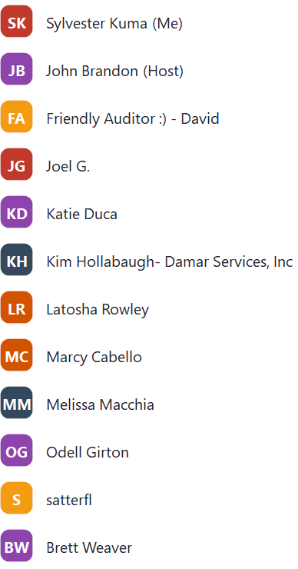
Opening
Fifteen thousand dollar check presentation from Old National Bank!!
Mental Health Matters update by Becky Reich
Motion to approve consent agenda was approved
2022 Audit Results and 2022 Tax Return review- David
Motion to conditionally approve the 2022 financial audit- Brett
Second- ???
Opposed- None
Motion to approve 2022 Tax return- Brett
Second- Sly
Opposed- None
2023 March financial results- Brett
Change in investment of cash balance to Sweep account and actively earning interest
Discussion on decisions to split cash assets between banks to reduce FDIC uninsured risk. Will be revisited by the Finance Committee and Board.
Motion to approve March financials- Brett
Second- Latosha
Opposed- None

Public Support Test Update- Brett
Fell below 33% threshold in 2022
Shared consequences of failing in 2023 as well- Would need to apply for a facts and circumstances exception from IRS
Failing this test again in 2023 could result in having to operate as a private foundation vs a public charity
Will be revisited by Finance Committee and Board

CEO Transition Update- Melissa/Linda/John/Latosha
Team is on track w.r.t. timing. In the process of reviewing position profiles with search process beginning in late May/early June. Will rely on Talbots database to attract applicants in a more strategic/deliberate search. Talbot has already started identifying short list of potential candidates.

Program Committee Update- Summer Youth Program Fund- Joy/Sly
Summer Youth program fund update shared
Strategic Plan Review- Linda
HATC Update- John
New venue selected- Crane Bay
Nov 2nd date for event

Motion to end the meeting- Linda
Opposed: None

