Minutes of the February 22, 2023 Board of Directors Meeting
Marion County Commission On Youth, Inc.

Attendance:
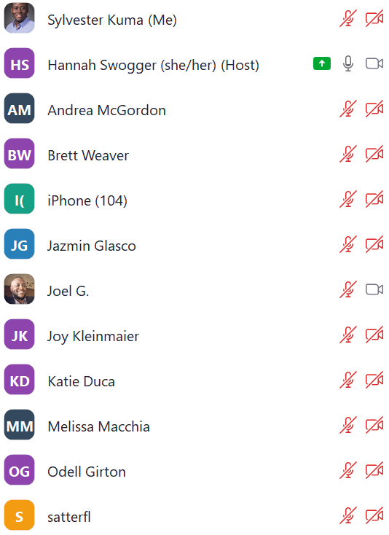
iPhone (104) above is Mike Simmons

In person: Marcie, Sly, Linda, Suzanne Dillon

I. Approval of consent agenda minus the December 7th minutes- Approved (Mike/Marcie)
12/7/22 minutes to be approved at April meeting

II. Finance update
2022 Actuals
Cash balance increased by 400k year over year from 12/31/2021 to 12/31/2022
Action: Committee will share investment opportunities, including possibilities for 2022 net income, at April meeting
Jan 2023 Budget
Revisions: 60k Lilly endowment - Youth worker well-being grant; 25k CICF for building executive management skills
Income statement: YTD behind budget on revenue and expenses. No concern as we will see recovery in summer months
General Updates:
Annual audit beginning March, Audit report at April meeting
Cash balance investment options- Bank of Indianapolis, exploring other options
Motion to approve January Financials- (Brett/Joel)- approved
Motion to approve signatories for bank being John, Brett, Linda- (Brett/Joel) approved

III. Strategic plan update
All components are underway with impact measurements being scheduled for this year. Plan is for a Mid-2023 review of original intent of strategic plan vs where we are in executing it
Action: Executive Committee to update dashboard with clear indication of level of completion compared to timeline for April meeting requested to have a better way of assessing and communicating status of priorities

Committee Strategic Plan Updates
Committee chairs shared updates on committee work to address their respective impact measurements
Mike/Resource development: Identified goals for the year, subset of committee working on HATC, one goal this year is to deepen relationships with corporate donors.

Public policy- No report provided

Brett/Finance committee: Discussed different KPIs to present to the board to give everyone visibility on key financial indicators of strength of the organization, resource development staff member will follow through in alignment with strategic plan, benchmarking against other nonprofit organizations, creating a feedback loop from the board to the finance committee

Sly and Joy/Program:- Shared Attendance Policy assessment Program review and Closing the Gap Initiative program review. Feedback received from board members to share the program review worksheet at future board meetings.

Other business
Establish an Equity & Diversity committee as a committee of the board (Charter, scope, function definition)- No objection from the Board to taking this step. The Governance Committee will work with existing task force to move forward with creating a charter and scope statement.

30th Anniversary committee- will behave as an advisory group, not a committee. We need a few additional board members to engage in plan development (Need commitments by 2/27)
Meeting adjourned at 6:00 PM

Respectfully submitted,

Sylvester Kuma, Secretary

